Palo Alto OS Upgrade step by step Process
CRQ00000515633 – Upgrade GSIL Firewalls to PAN-OS 11.1.4-h18
Log into Citrix
- QA - https://workspaceqa.sce.com/Citrix/SCEGridStore_QAWeb/
- PROD - https://workspace.sce.com/logon/LogonPoint/tmindex.html
- GSIL -
Log into PAN
- QA
- PROD
- GSIL
Log into Spectrum using Citrix / .26
- https://oneclick.gnscet.com:8443/spectrum/admin/index.jsp
- Prod / https://alhxvprcasoc03:8443/spectrum/webapp
- Prod : https://oneclick.gnsce.com:8443/spectrum/
- ID: gutiers@gnsce
- ID: gutiers@gnscet
- PW – Pin / Token
One Note
- PAN OS Upgrades
Palo Alto calendar
- https://intranetsps.prod.edisonintl.com/sites/it/gridcsn/Change%20Management/NSO%20Reference/PAN-OS%2011.1.4-h18%20Upgrade/11.1.4-h18%20Schedule%20Summary.xlsx?d=w388921f2951f4c9b86986e788633d762
Sharepoint
- 2023 - All Documents (edisonintl.com)

GSIL: Grid Services Integrated Lab
Before outage / Prep
- Evidence
- Checksum
- Store both in NERC Sharepoint Folder
To Download versions from Pan (Can be processed before Date of outage)
- Panorama
- Left hand panel / Device Deployment / Software
- Find version you need
  - Make sure of device model ex: PA-3260 will need PanOS_3200 versions
  - If you don’t see version click on Check Now
- Click on Validate
  - If validate is not an option / Click on download. Once download is complete / Validate option will now appear
- 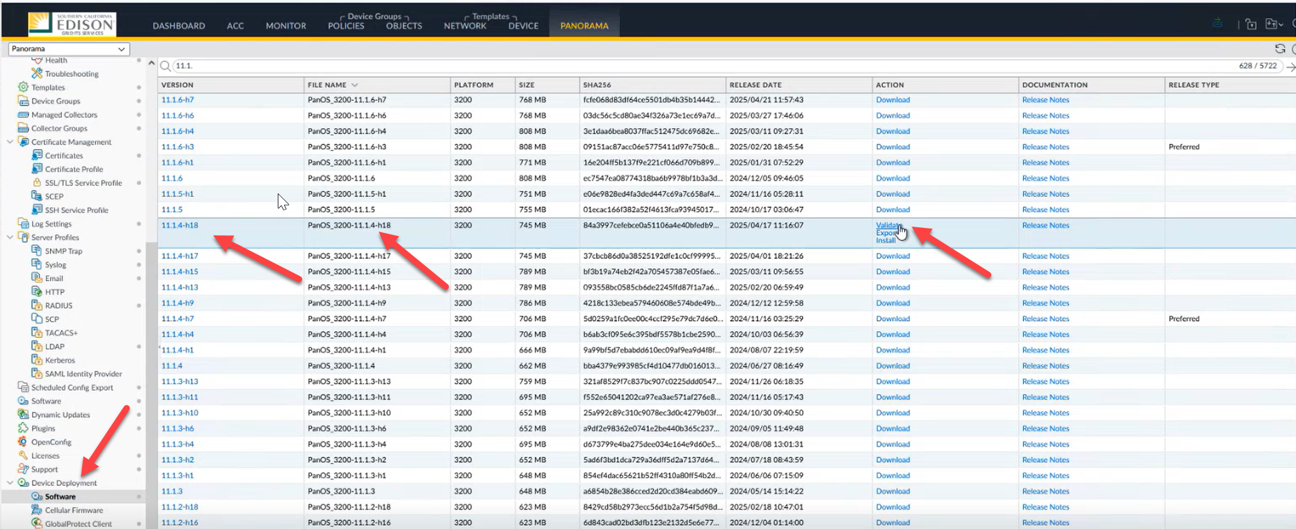
- This will bring up new window ( Required Deployment ) / Type in device / click on deploy / click on download
- 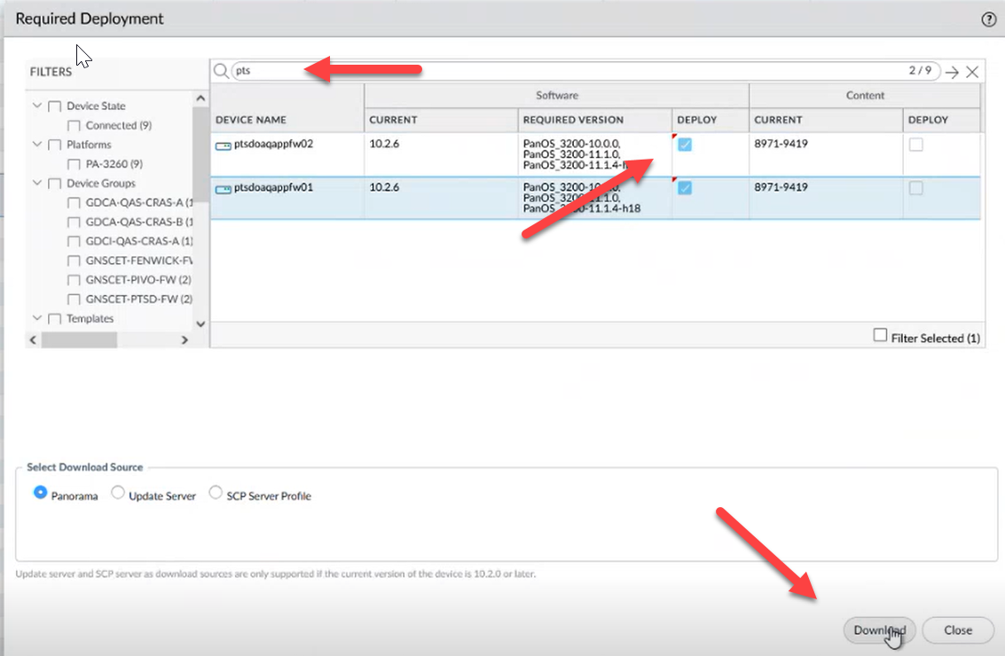

During download / Log into Secure CRT to monitor progress
Type in / show jobs all
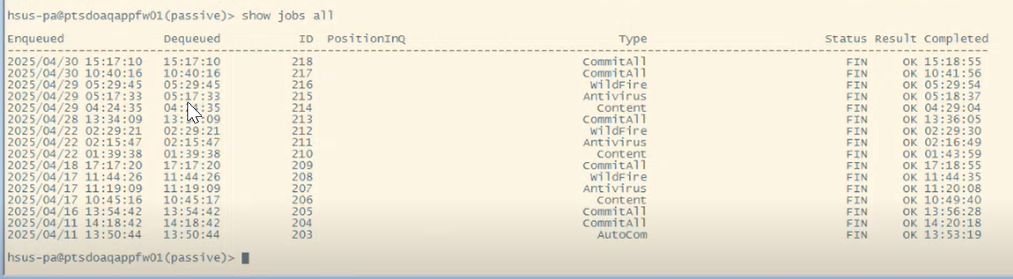
Type in / request system software install version – This will tell you what version we have on device
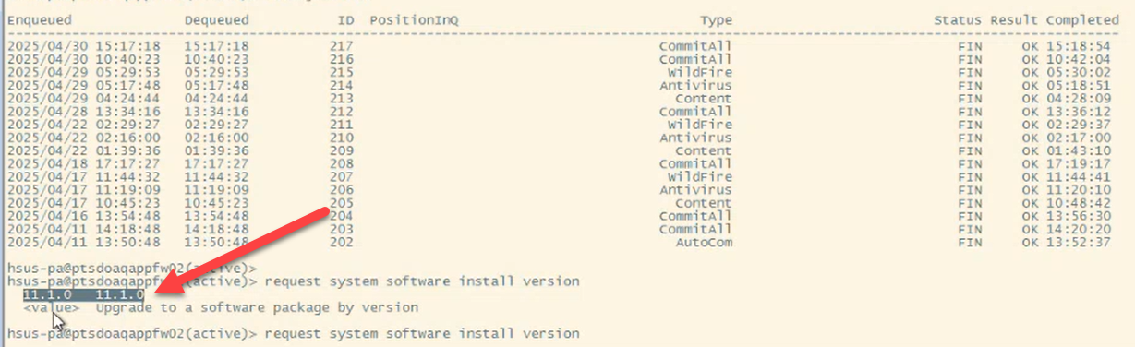

Make sure to update One Note with all times of actions
- GSIL Lab

- MOP:
- Capture Pre-Evidence
- CIP-10 Software Integrity Check Sum
CA-Spectrum Maintenance Mode
Id : gutiers@gnscet.com
Pw: Pin/RSA
- Click on device in left panel / Information tab/ In maintenance / Click on set
- 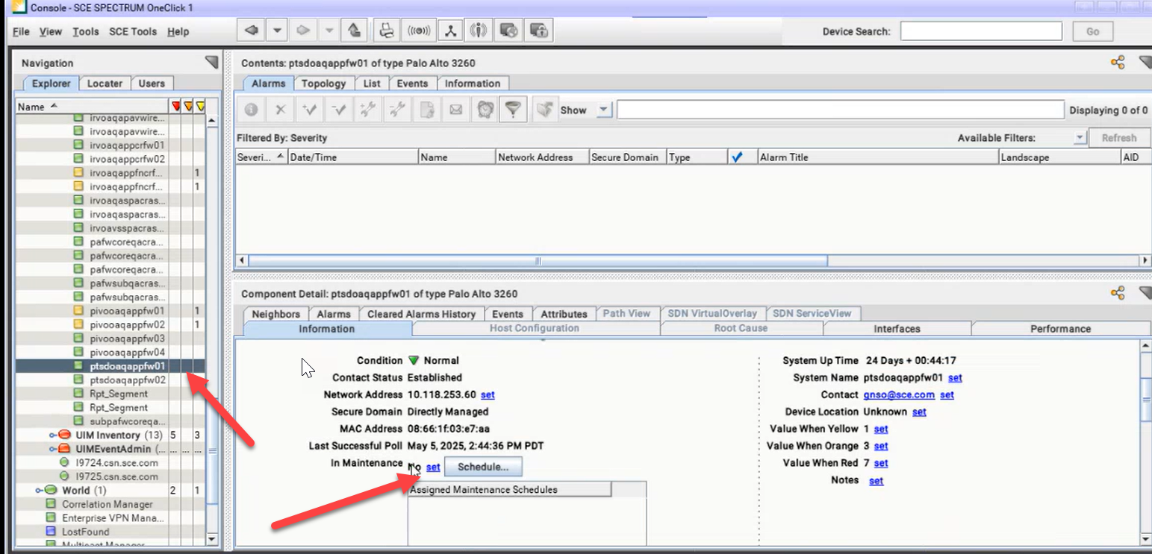
- Will bring up pull down menu / Click on Yes
- 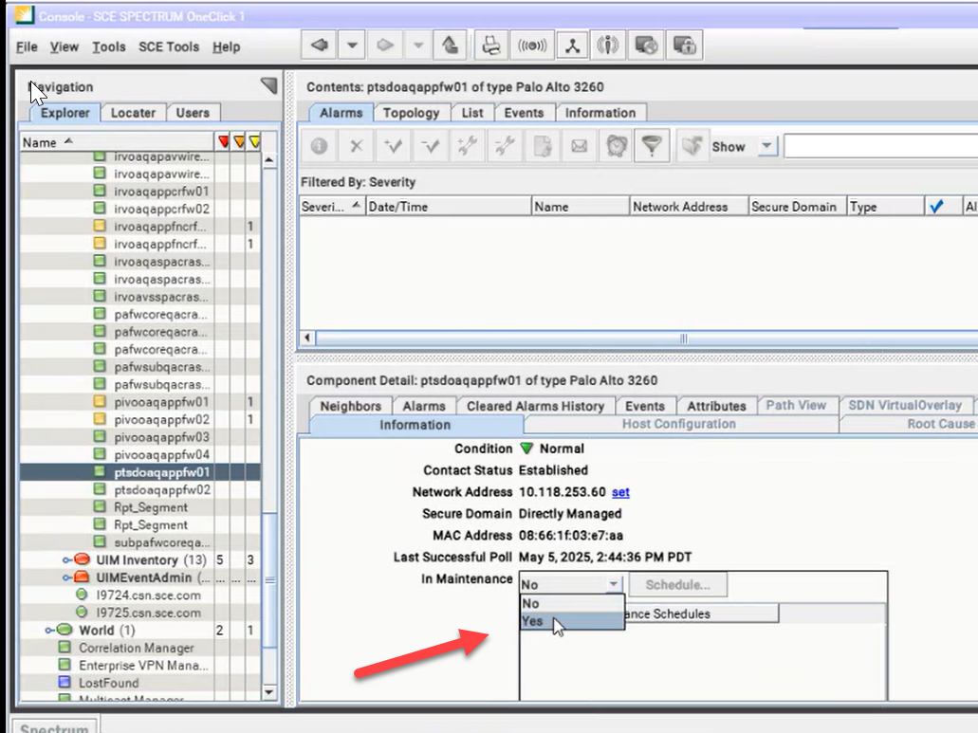
- Status will be yes and Device will turn yellow
- Do to both devices in set ( Active / Passive )
Install Process
Process Passive side first
Backup FW Configurations
In device PA
- Device/ show jobs all
- Setup / Operations / Save: Save named configuration snapshot (Click on ) / Will bring up Named Configuration box – click on pull down, find device and put in current date / click ok
- 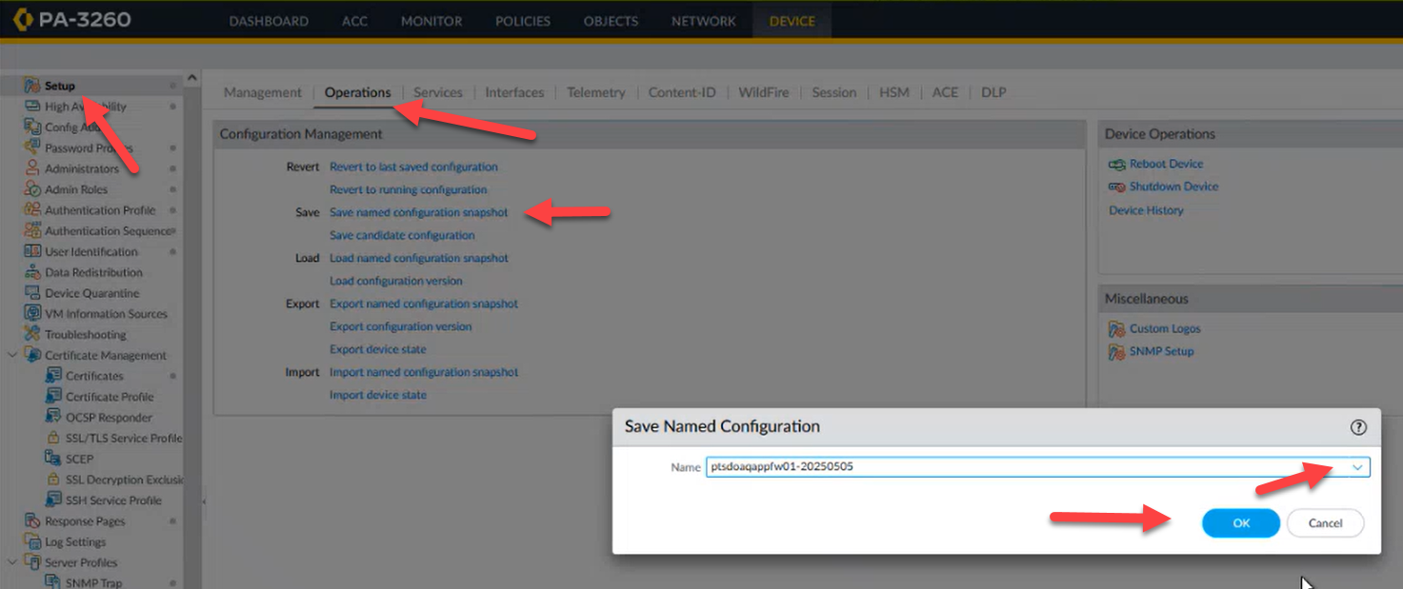
- Click on close
- 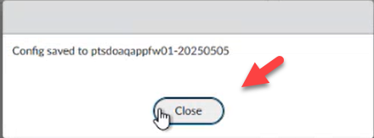
- Click on Export: Export named configuration snapshot / Will bring up Export Named Configuration box – click on pulldown, find device and date / click on OK
- 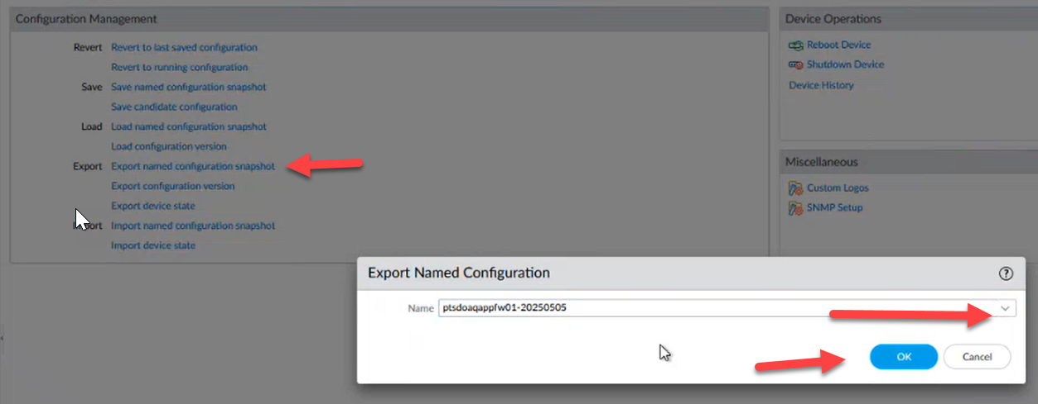
- Click on Export: Export device state
- 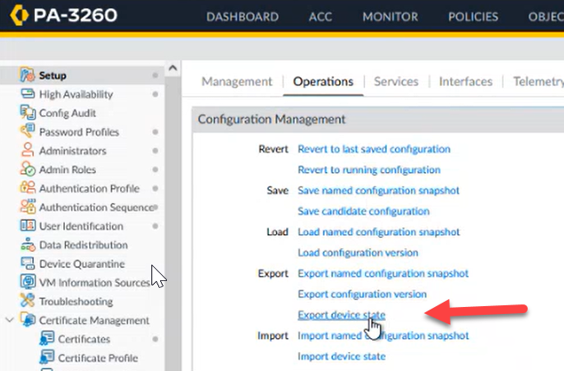
CRI Output
- Secure CRT / Log into device
- 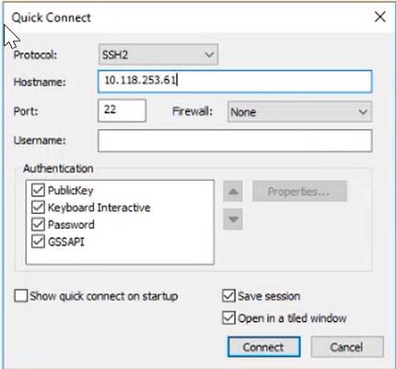
- 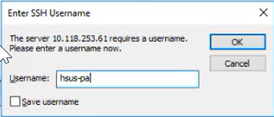

- Call GSOC
- Send Email Notification
Start outage
Find out which to do first / You want to do Passive side 1st
- Log into each device using IP Address
- Make a note of ports .
- Spectrum
  - Put in Maintenance
- To find active in PA dashboard/high availability – Local (Active)
- 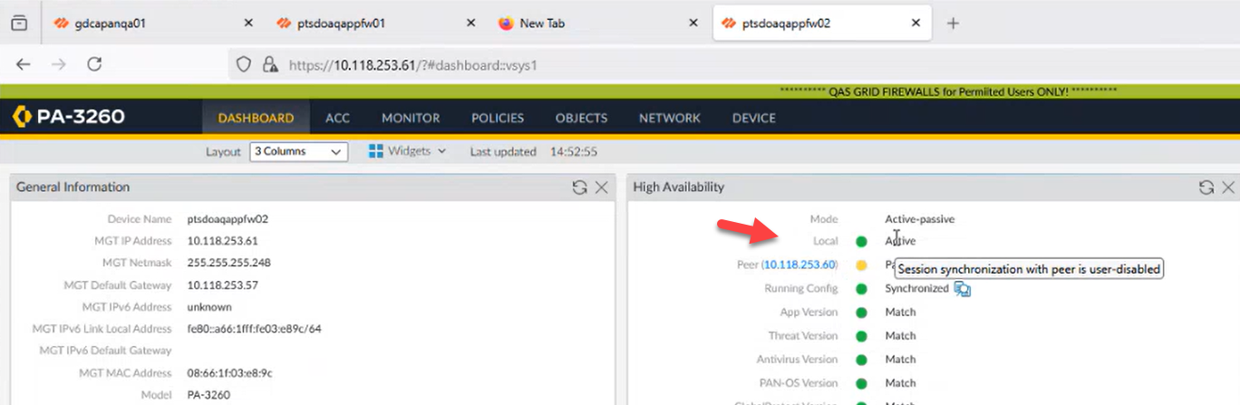
- Process Passive firewall first
- Suspend Passive firewall
  - Device / High Availability / click on Suspend local device for High Availability
  - 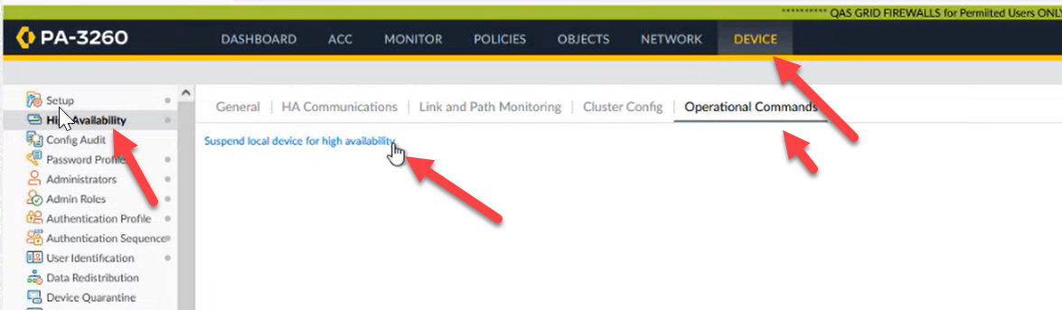
- Click on OK
- 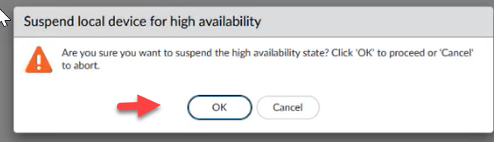
- Verify device is in suspend mode Dashboard / High Availability

- 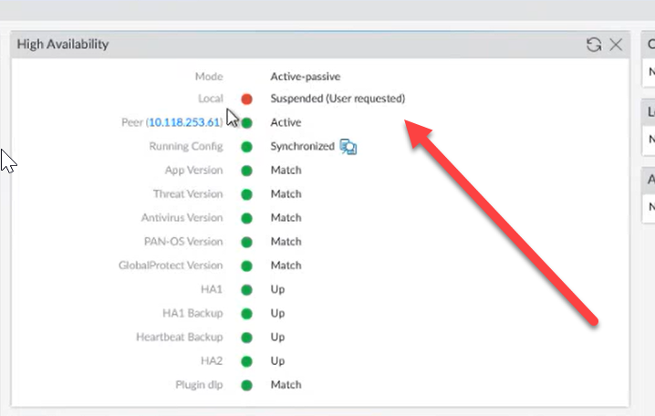
- Verify active device Peer should now read Suspended
- 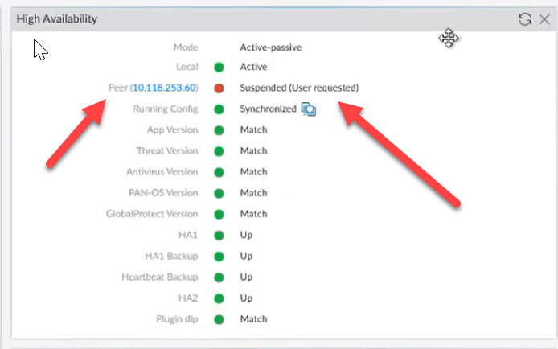
- Make a not of ports affected to verify they come back up after outage
- Ports being used will be green. Check after reboot to verify same ones are up.
- 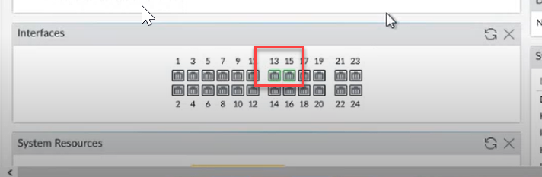
- Check to make sure traffic is still flowing
To start outage / Install
- Check to see if device has version PAN-OS 10.2.6
- Check to see what version is on device . Dashboard / General Information
- 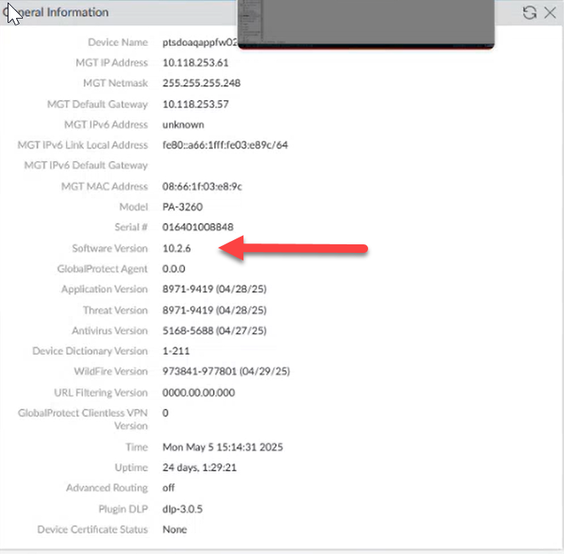
- Install PAN-OS 11.1.4-h18
- Left panel Device / Software / look for 11.1.4-h18 / Click on install
- 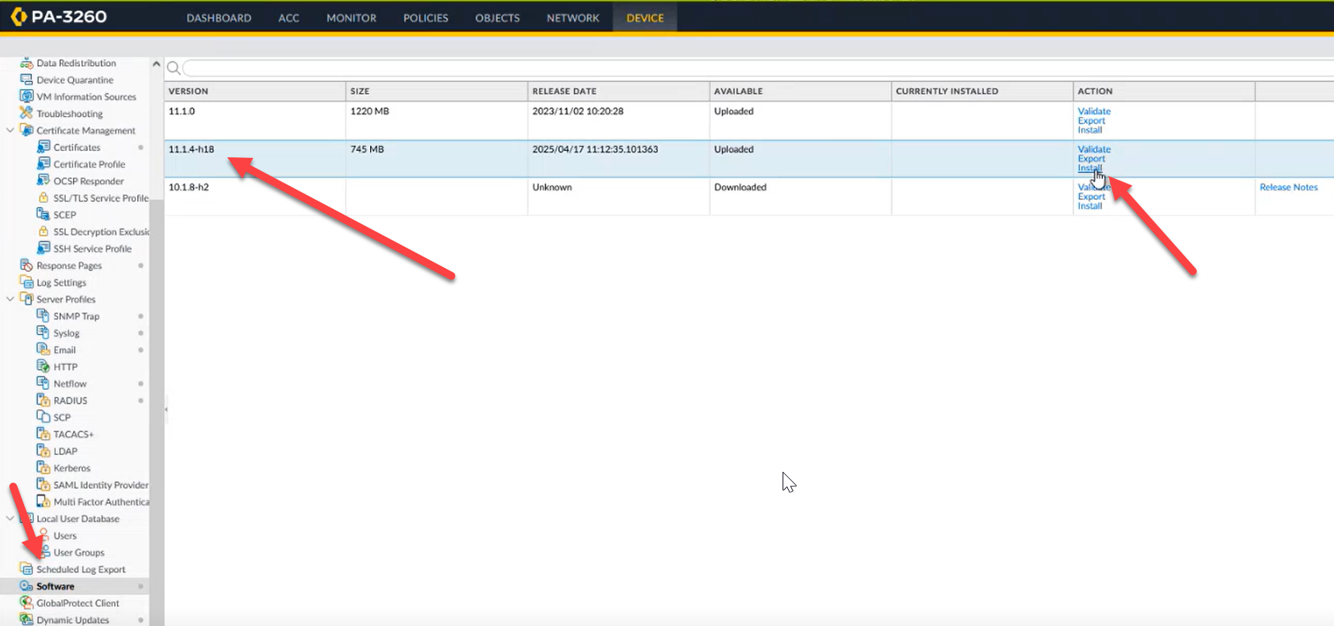
- Click on OK
- 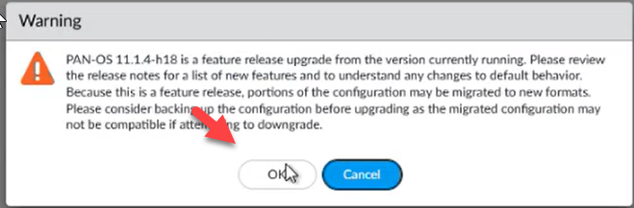
- You can see Status
- 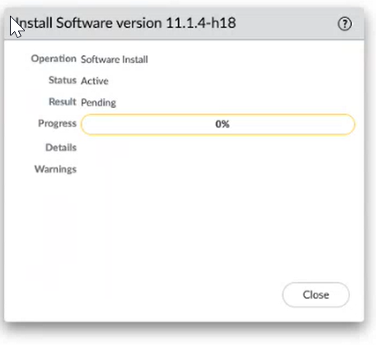
- Open up Secure CRT
- Type / Show jobs all
- You are looking at the type area / SWInstall
- 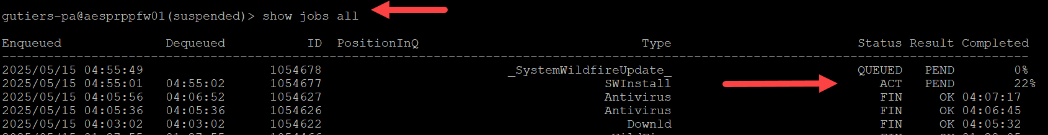
- When completed you will receive Reboot request
- Before you start reboot go back to Secure CRT
- Go Back to Secure CRT / check status of SWInstall / Should be FIN / OK
- 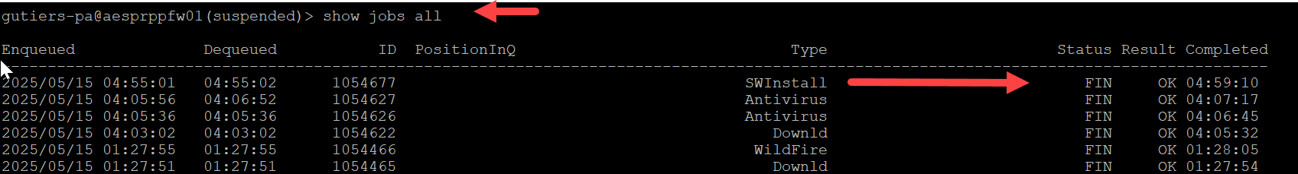
- Click on Yes to start reboot
- 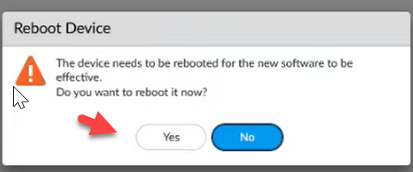

- To find status / go to active look at Dashboard / High Availability / click on refresh/ It will turn yellow. You will know when Reboot completes. On opposite device all areas will turn green except for mismatches (Which s to be expected)
- 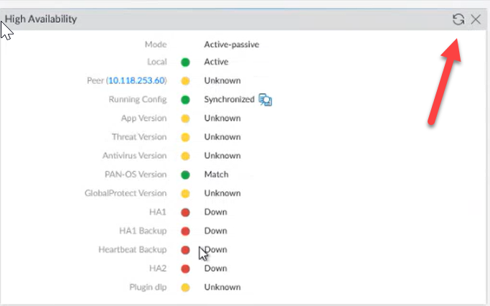
- Once it comes up / Log into device again / checking for new version
- 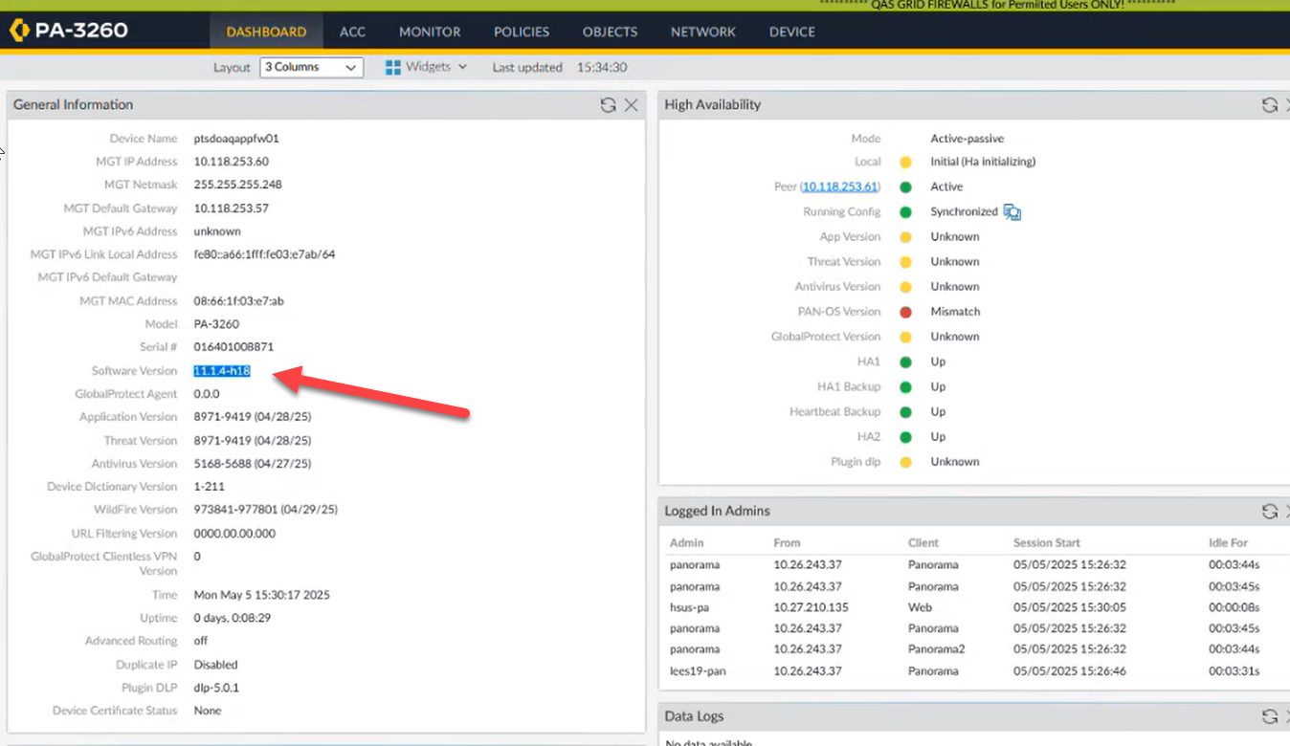
- To verify everything came up / Reconnect to Secure CRT
- Show clock / show system info / Show jobs all
- Show jobs all – look for Autocom – It should show Status : FIN / Result – OK
- 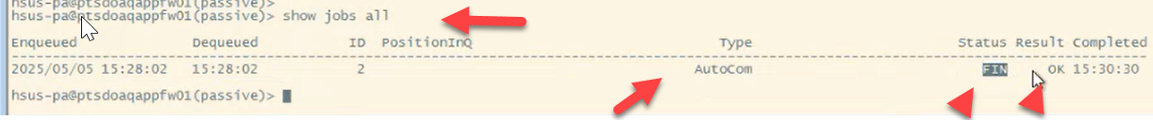
- Verify ports are up. Should be same ones as before outage
- 
- Pull up info
- Mismatches are expected. Active will have a different version
- 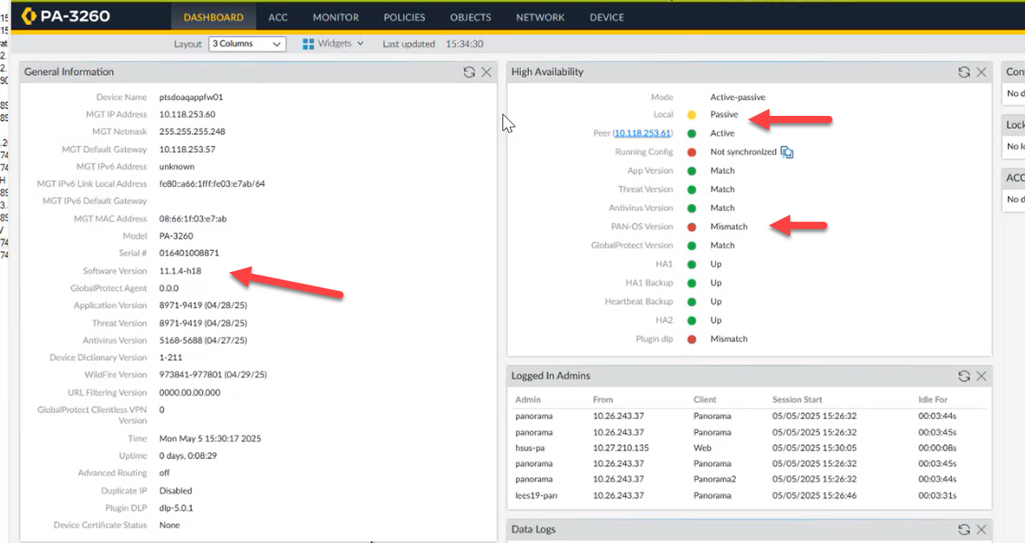
Active Firewall Install
- Go to active firewall / Device / High Availability / Operational Commands
- Click on Suspend local device for High Availability
- 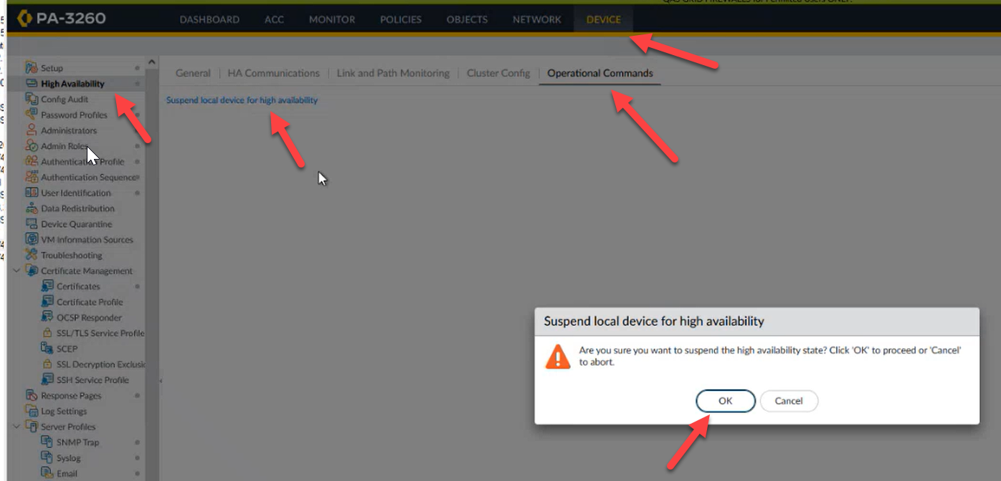
- Dashboard – Should now read / Local is Suspended/ Peer is Active
- 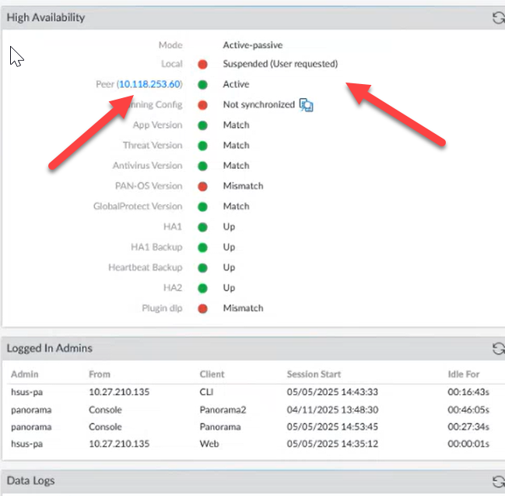
- Double check that Active one is picking up traffic
- Monitor / Traffic – look at receive time – You might have to click on refresh
- 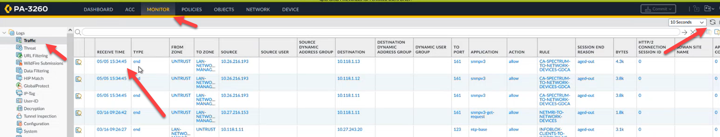
- Now you can start Install on 2nd device
- Same process as 1st
- The lowest device is usually the Active
- Open up Secure CRT
  - Show clock / set cli pager off / show system info / show cli info
  - 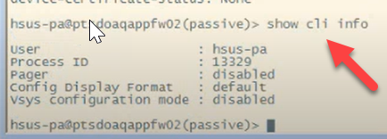
- Setup / Operations / Save: Save named configuration snapshot (Click on ) / Will bring up Named Configuration box – click on pull down, find device and put in current date / click ok
- 
- Click on close
- 
- Click on Export: Export named configuration snapshot / Will bring up Export Named Configuration box – click on pulldown, find device and date / click on OK
- 
- Click on Export: Export device state
- 
CRI Output
- Secure CRT / Log into device
- 
- 
- Suspend firewall
  - Device / High Availability / click on Suspend local device for High Availability
  - 
- Click on OK
- 
- Verify device is in suspend mode Dashboard / High Availability

- 
- Verify device should now read Suspended
- 
- Make a note of ports affected to verify they come back up after outage
- Ports being used will be green. Check after reboot to verify same ones are up.
- 
To start outage / Install
- Check to see if device has version PAN-OS 10.2.6
- Check to see what version is on device . Dashboard / General Information
- 
- Install PAN-OS 11.1.4-h18
- Left panel Device / Software / look for 11.1.4-h18 / Click on install
- 
- Click on OK
- 
- You can see Status
- 
- Open up Secure CRT
- Type / Show jobs all
- You are looking at the type area / SWInstall
- 

- When completed you will receive Reboot request
- 
- Go Back to Secure CRT / check status of SWInstall / Should be FIN / OK
- 
- To find status / go to active look at Dashboard / High Availability / click on refresh/ It will turn yellow
- 
- Once it comes up / Log into device again / checking for new version
- 
- To verify everything came up / Reconnect to Secure CRT
- Show clock / show system info / Show jobs all
- Show jobs all – look for Autocom – It should show Status : FIN / Result – OK
- 
- Verify ports are up. Should be same ones as before outage
- 
- Pull up info
- Device will have a different version

- 
To Make FW01 the active FW / Dashboard look at Dashboard on Active device EX: fw02 / High availability , if FW02 is active , Change to Passive state
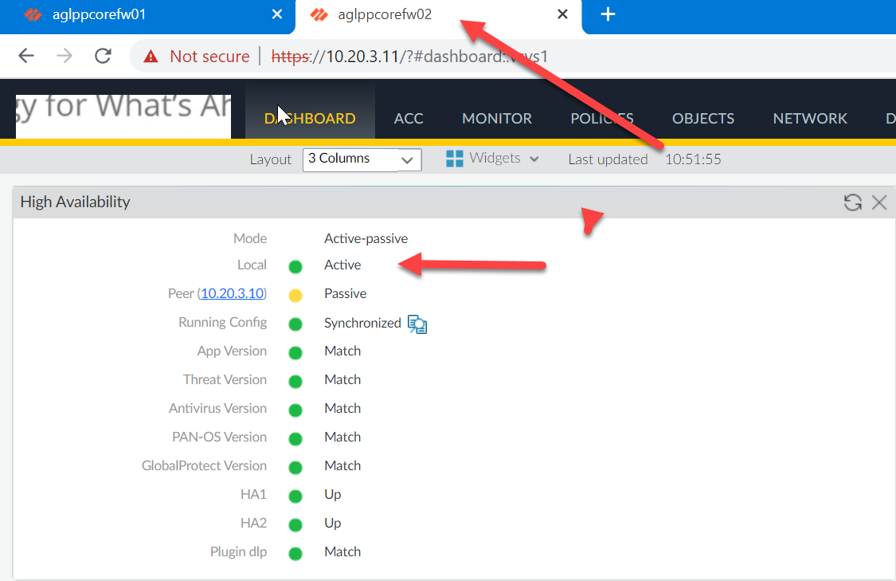
On Active device (EX FW02) Device / High Availability/ Operational Commands/ Click on Suspend local device for High availability
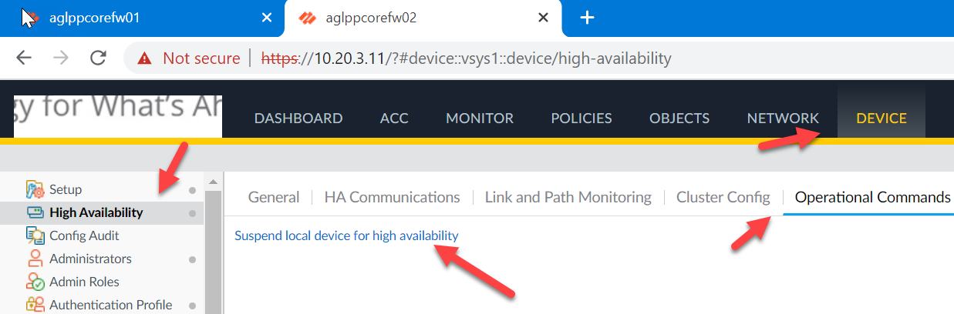
Click on OK
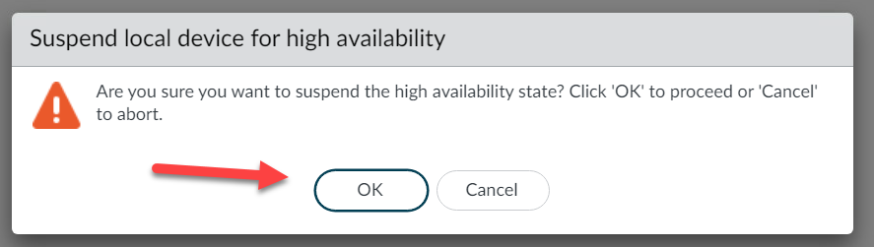
This will change display / Click on Make local device functional for High Availability
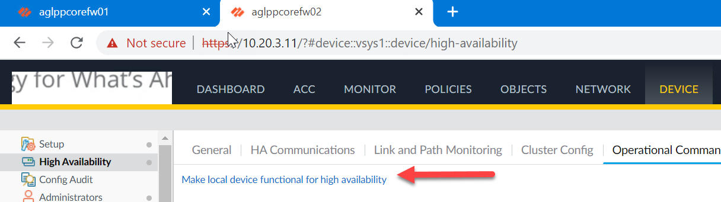
Now Dashboard will read that FW02 is in Passive state / FW01 is now in Active state
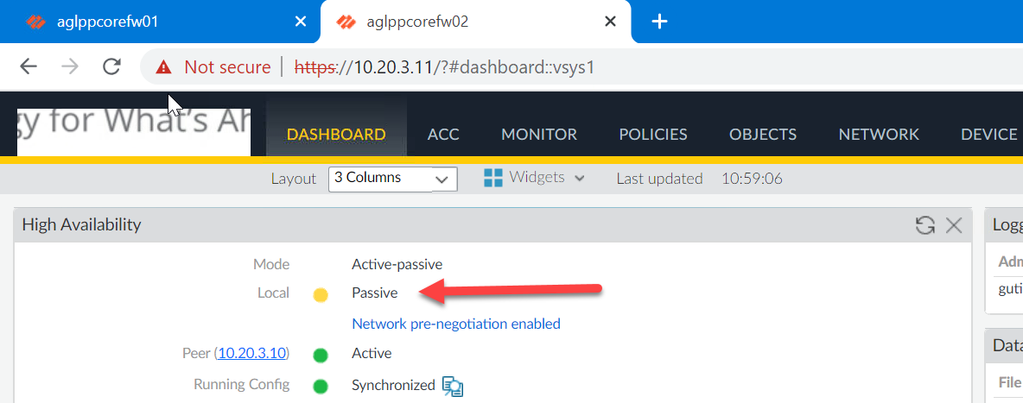
Confirm traffic is passing on active device
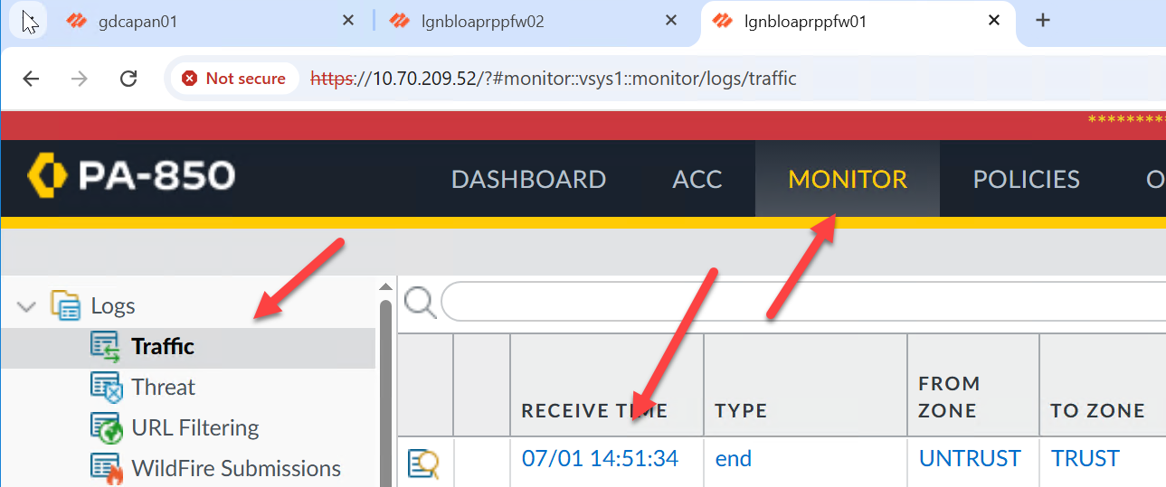
To Close out CRQ
Open Helix / Remedy / More – Release Management
- This will open up
Log into device
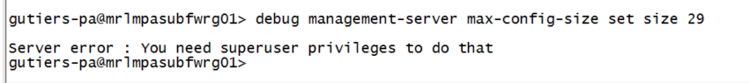
Issue show commands:
- Show clock
- Set cli pager off
- Show system info
- Show cli info
- Show jobs all
Debug Command needs to be issued on PA 850 devices after completion of upgrade
